LINUX ASSIGNMENT

Gokula Madhavan B

Department of Information Technology

Sri Sairam Engineering College, chennai

1. **BASIC COMMANDS:**

Commands are actually files containing programs, often written in C. How will you find out in which directory does the file corresponding to the man command resides?

**ANS: type man**

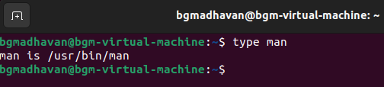

How will you find out what is the use of the ps command.

**ANS: man ps or whatis ps**

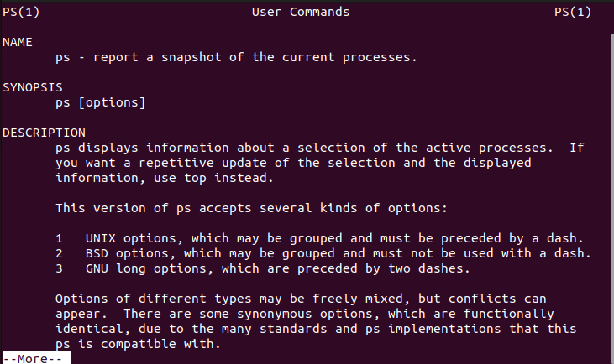

**C:\Users\bgmad\Pictures\Screenshots\Screenshot 2023-09-14 114232.png**

1. **GENERAL UTILITIES:**

1)Display the calender for the month of March 2012

**ANS: cal mar 2012**

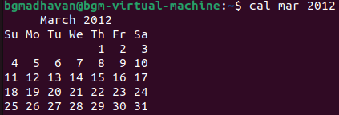

2)List all the files and directories of the directory /usr/lib on the terminal. Now put the same information in a file named results.

Display the contents of the file results now.

**ANS: ls /usr/lib**

**ls /usr/lib –l > results**

**cat results**

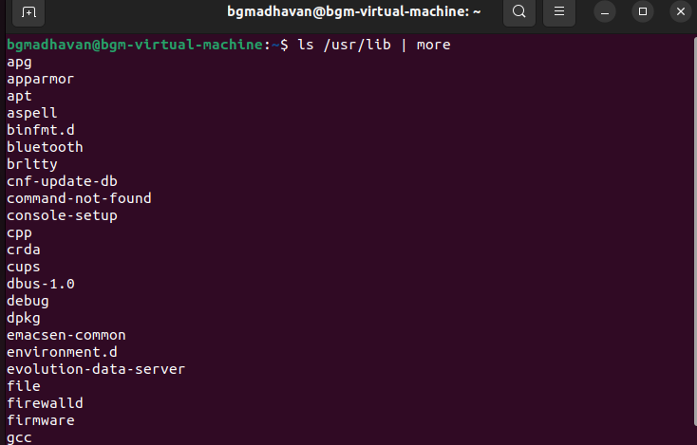

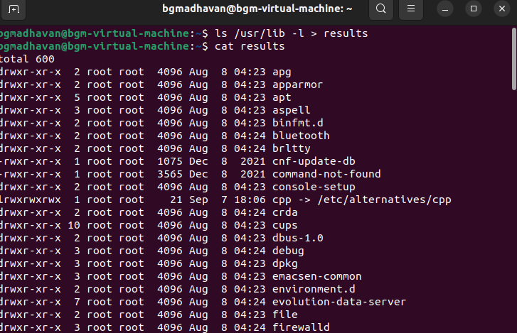

**3.File System**

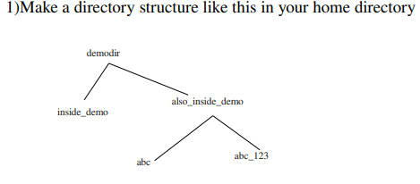

**Ans: mkdir demodir**

**cd demodir**

**mkdir inside_demo also_inside_demo/abc abc_123**

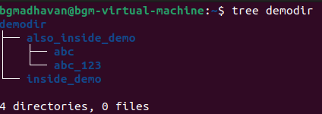

2) Remove the also_inside_demo directory

**Ans: cd also_inside_demo**

**rmdir abc abc_123**

**cd ..**

**rmdir also_inside_demo**

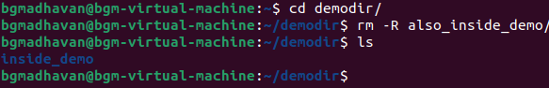

1. **FILE ATTRIBUTES:**

1. Create a file abc.txt and change the ownership of this file to some other user on your machine,

and also change the group to family.

**Ans: cat > abc.txt**

**sudo chown newowner abc.txt**

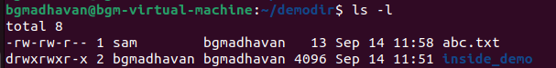

2. Create a file exercise.txt and make it executable.

**Ans: cat > exercise.txt**

**chmod =x exercise.txt**

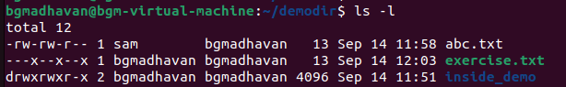

3. Create a file test.txt on your desktop and identify its inode number, also create a softlink for test.txt in your home.

**Ans: cat > test.txt**

**ls –i test.txt**

**ln –s text.txt soft.txt**

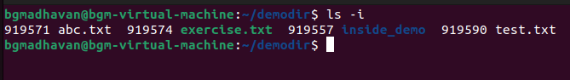

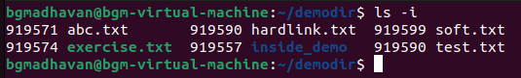

**5.Redirection pipes:**

1. Create a file name error_log in your current directory. Suppose you do not have any file named aa11 in your current directory.

How can you redirect the error message to the file error_log when we apply the command "wc -l aa11" ?

**Ans: wc –l aa11 > error_log.txt**

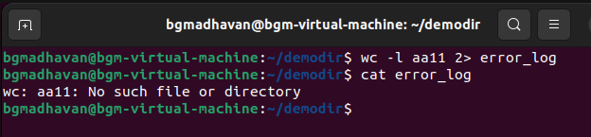

How can you ensure that all the error log are appended to the error­log file?

**Ans: wc –l aa11 >> error_log.txt**

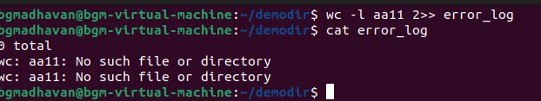

2. Create files named test1, test2, testa, testb

How can you count the number of files starting with test and then having only one digit in their name using only a single line command ?

**Ans: cat > test1**

**cat > test2**

**cat > testa**

**cat > testb**

**command: ls -1 test[0-9] | wc -l**

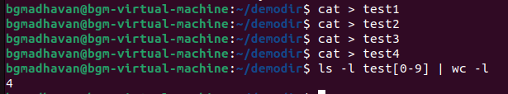

1. **Working with Linux Process:**
2. Open a terminal. Now spawn three shell processes one after another i.e. first spawn one shell, then from the spawned shell, spawn one new shell and so on. Now, how can you see the PID of the current shell ? How can you see the PID of the shell which is the grandparent of the current shell?

**Ans: open a terminal enter command ‘bash’**

**Enter bash again to get child terminal**

**To get PID of current terminal: echo $$**

**To get PID of grandparent : pstree –p | grep PID_of_current bash**

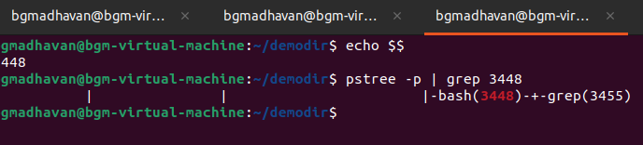

1. How can you see all the processes (both system & user processes) in your computer? The output can be quite large. How can you view the output as multipage output ? How can you store the output in a file named process_info?

**Ans:To view all the process: ps –ef**

**Multipage output: ps –ef | less**

**Ps –ef > process_info**

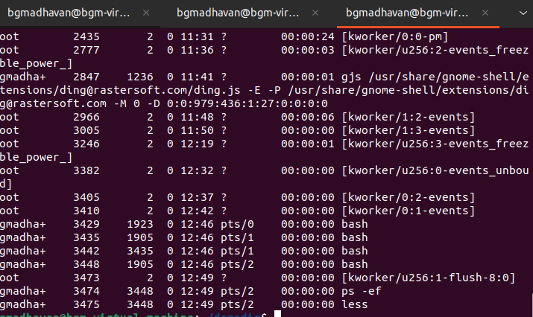

**7 .Linux Environment**

1. How can you know what is the secondary command prompt set your system ?How can you change the secondary command prompt from the default to your username ?

**Ans: echo $PS2**

**To set ps2 to our username: PS2=”$USERNAME> ”**

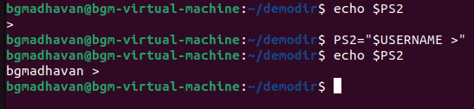

2.How can you ensure that the mv command (used for renaming a file) always asks for permission before overwriting an existing destination file ?

**Ans: mv –i file1 destination.**

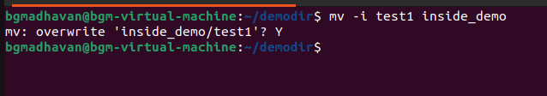

1. Create a new user account and home directory called "Duck"

**Ans: sudo adduser**

**Enter the password**

**Sudo adduser Duck**

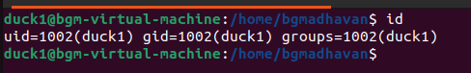

1. Set the user account "Duck's" expirey date as 07 - 01 – 2015

**Ans: sudo usermod –e 2015-01-07 duck**

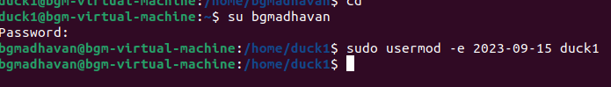

1. find the id of the user account "Duck"

**Ans: id -u duck**

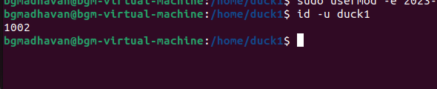

1. Type df and du commands and see the output on your terminal.

**Ans: df**

**Du**

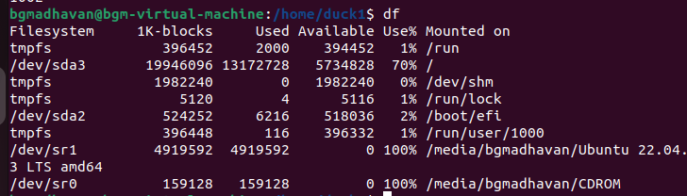

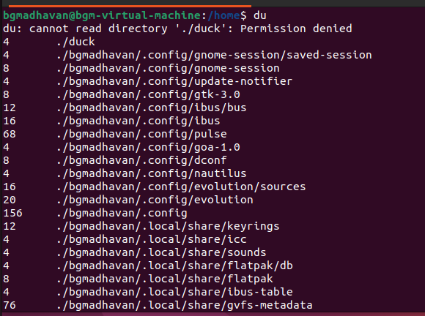

5) Type this command on the terminal and see the output :

du -ch *.txt

**Ans: du –ch *.txt**

6) Delete the user account "Duck" permanently along with its home folder.

**Ans: sudo userdel –r duck**

**8.Simple Filters**

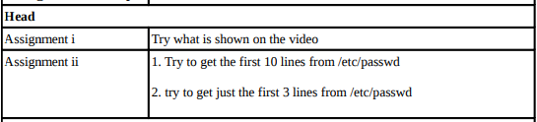

**Ans: head /etc/passwd**

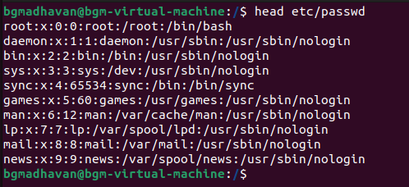

**head –n5 /etc/passwd**

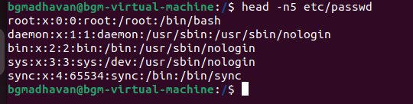

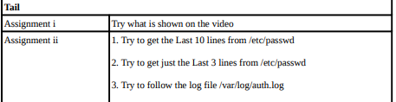

**Ans: i) tail etc/passwd**

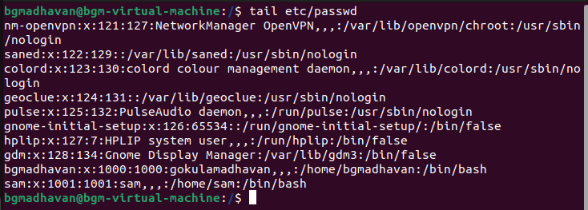

**ii) tail –n3 etc/passwd**

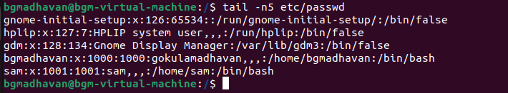

**iii)tail –f /var/log/auth.log**

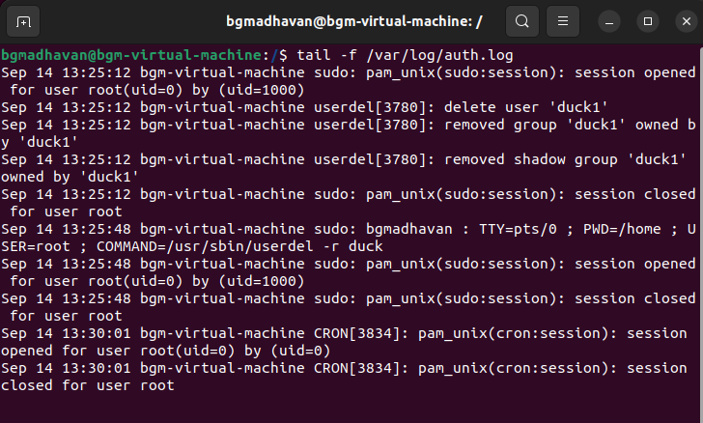

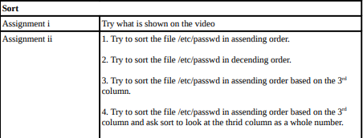

**Ans: i) sudo sort etc/passwd**

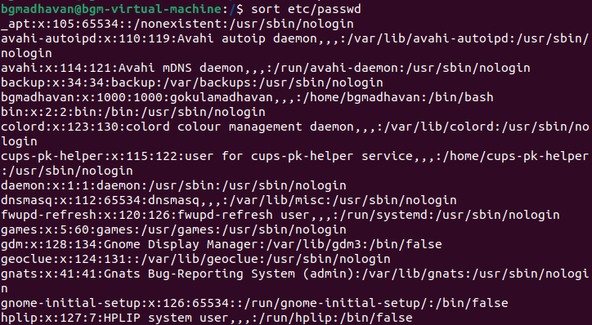

**ii) sudo sort –r etc/passwd**

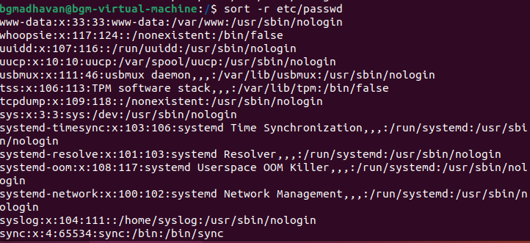

**iii) sudo sort –t: -k3,3 etc/passwd**

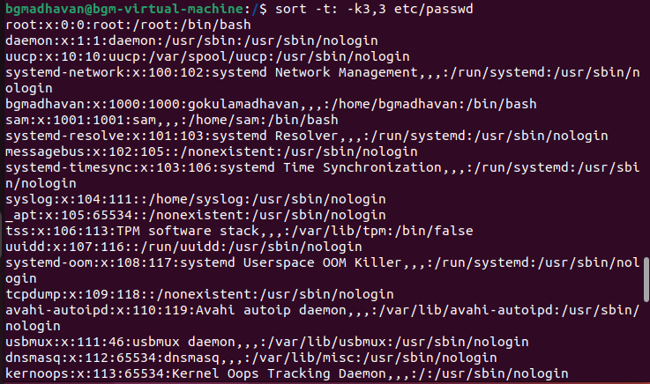

**iv) sudo sort –t: -k3,3 etc/passwd**



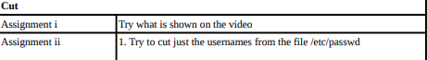

**Ans: cut marks.txt –d “ “ –f2**

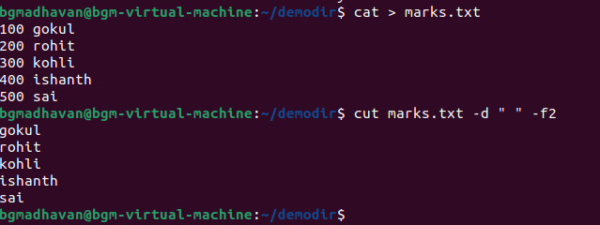

**sudo cut etc/passwd –d: –f1**

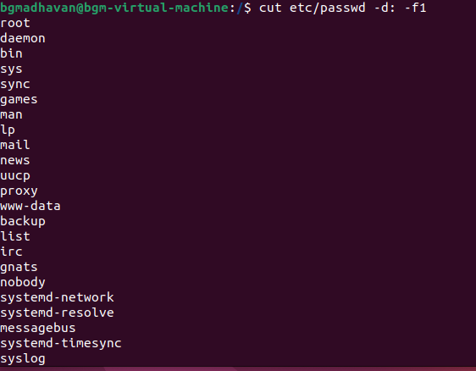

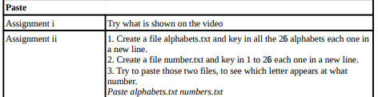

**Ans : i) paste numbers.txt marks.txt**

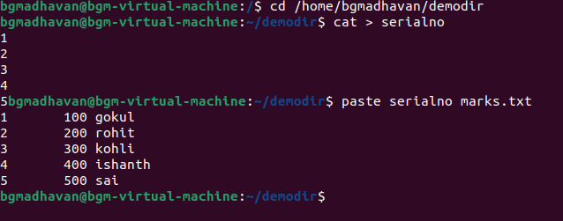

**ii) 1. Cat > alphabet.txt**

**2. cat > number.txt**

**3. paste alphabets.txt numbers.txt**

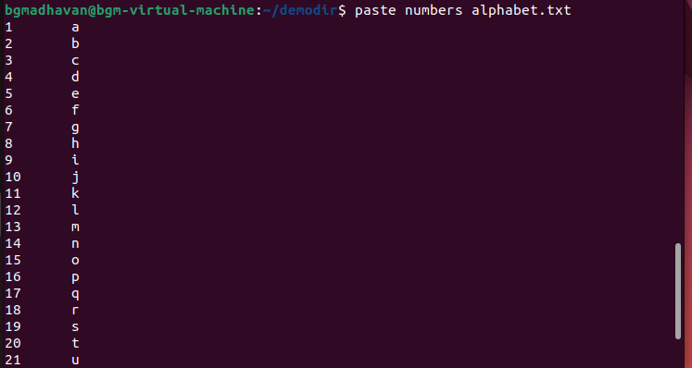

**9. Grep command**

1) Explore some other commands like -E, + and ?

**Ans: -E – extended regular expression: it is used to find longer more complex patters when used with other meta characters such as ‘+’ or ‘?’**

**‘+’ – it is a meta character used to find continuous occurrence of some patters ex: grep –E ‘[a-z]+’ text.txt**

**‘?’ – another meta character that acts like a ternary operator**

**Ex: grep –E ‘colou?r’ text.txt**

**10. More on grep command**

1) List those entries that are 5 letters long and starts with Y

**Ans: grep –E ‘^Y[a-zA-Z]{4}$’ test.txt**

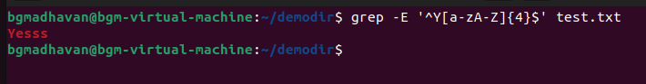

**11. sed command**

1) Use the same text file seddemo.txt

2) Try to print records from 6th to 12th line.

**Ans:sed –n ‘6,12p’ seddemo.txt**

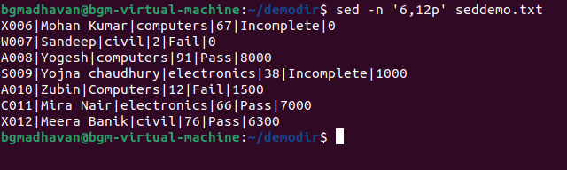

**12.More on sed command:**

1) Use the same text file seddemo.txt

2) Try to replace or substitute name Ankit with Ashish

**Ans: sed ‘s/ankit/ashish/g’ seddemo.txt**

